**Day 1: Setting the Goal**

On the first day, we focused on planning and defining the goal for templte-4 website that was on Furnitre. Our primary objective was to create a fully functional e-commerce platform that:

* Allows users to browse products.
* Enables customers to add products to their cart.
* Provides an intuitive interface for product details and checkout.
* Demonstrates payment and order completion processes.

We also outlined the website's main features, such as responsiveness, user-friendly design, and integration of APIs for dynamic data.

**Day 2: Technical Setup and Environment**

The second day was dedicated to the technical groundwork. Key achievements included:

1. **Setting up the project environment**:
   * Installed Next.js for a robust and fast front-end framework.
   * Configured Tailwind CSS for styling.
   * Initialized a GitHub repository for version control.
2. **Structuring the project**:
   * Created folders for components, pages, styles, and public assets.
3. **Designing the homepage layout**:
   * Added a navigation bar and footer for consistent design.
   * Designed the hero section with an attractive background.

**Day 3: Fetching Data from APIs**

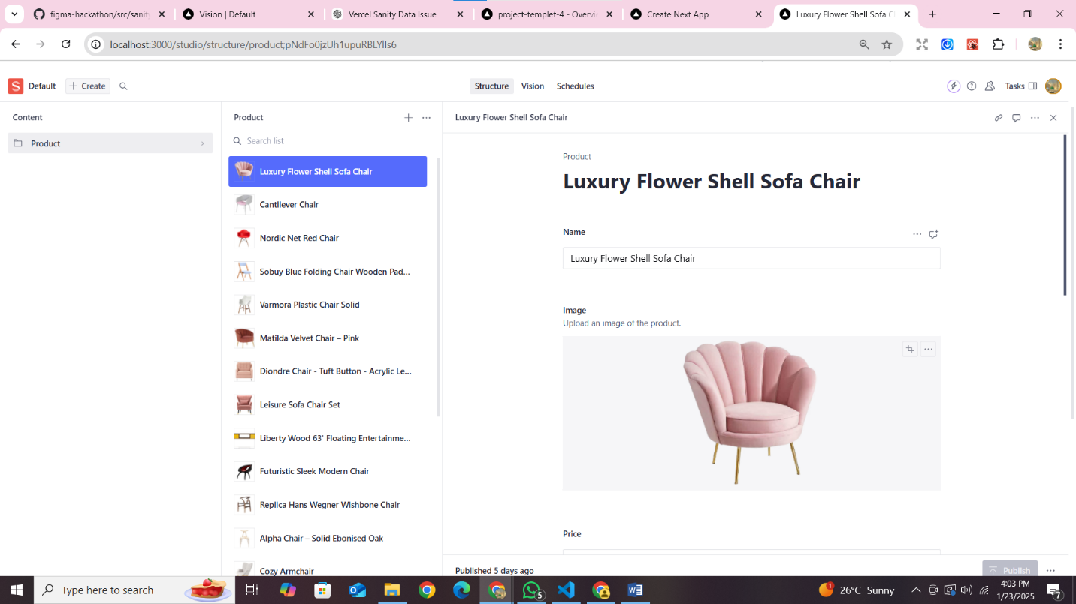

On the third day, we integrated APIs to fetch dynamic data for the website. Achievements included:

1. **Setting up an API key**:
   * Connected the website to a products API.
   * Retrieved product data such as name, price, and images.
2. **Displaying fetched data**:
   * Rendered a dynamic product list on the homepage.
   * Implemented basic styling for product cards.

**Day 4: Creating Components**

The fourth day was dedicated to building reusable components for essential website features. These included:

1. **Product Details Component**:
   * Displayed detailed product information, including description and price.
   * Added a section for customer reviews.
2. **Add to Cart Feature**:
   * Created a cart component to display selected products.
   * Implemented state management for adding and removing items.
   * 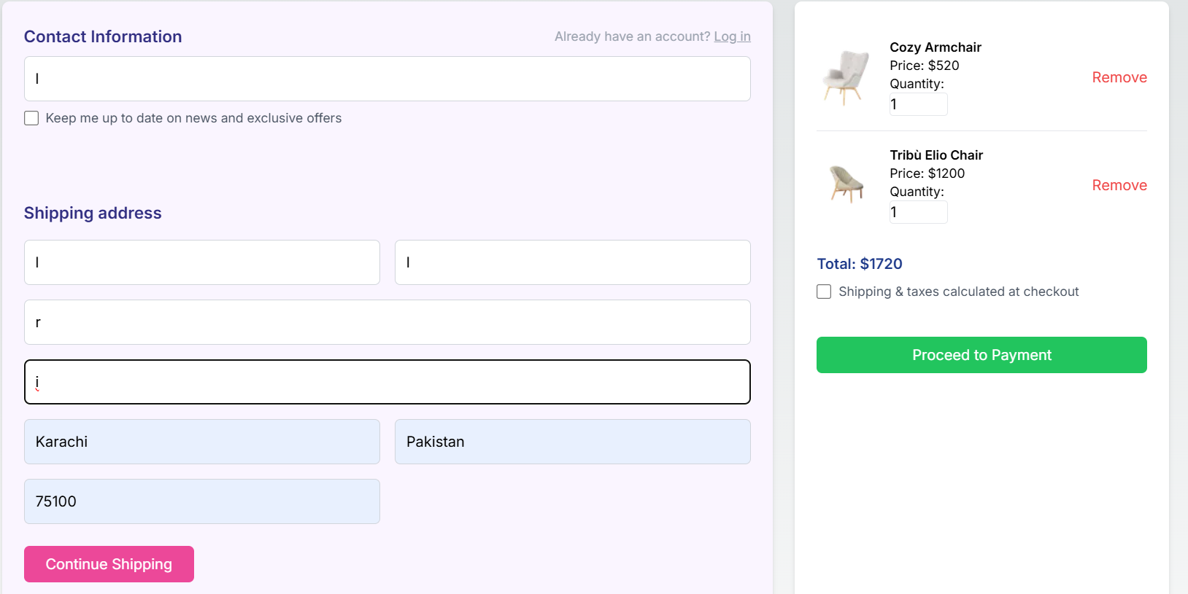
3. **Payment Demo**:
   * Designed a basic payment page layout.
   * Integrated a payment demo flow for testing purposes.
4. **Order Completion**:
   * Added an order confirmation component.
   * Displayed a success message after completing the payment.

**Day 5: Testing and Debugging**

On the fifth day, we tested the website for functionality and user experience. Key activities included:

1. **Bug fixes**:
   * Resolved layout issues in responsive views.
   * Fixed errors in the Add to Cart and Checkout flows.
2. **Performance optimization**:
   * Optimized API calls to reduce loading times.
   * Minimized CSS for better page speed.
3. **User testing**:
   * Conducted mock user testing to ensure smooth navigation and usability.

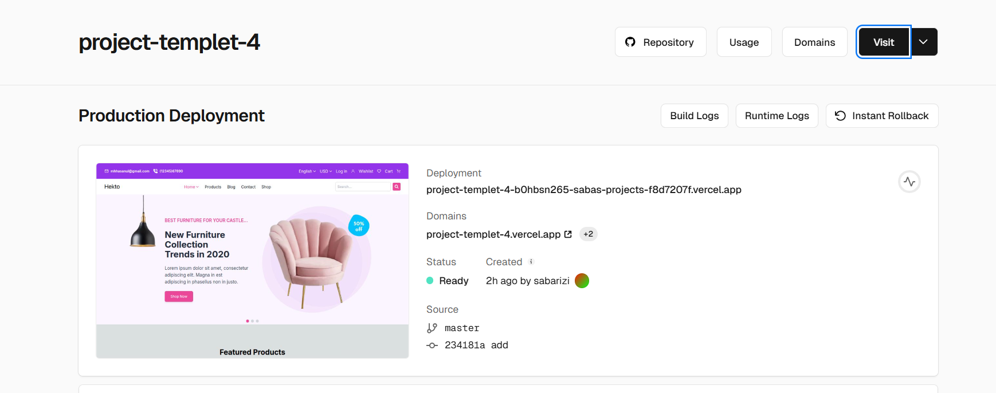

**Day 6: Finalizing and Deployment**

The final day focused on completing the website and making it live. Activities included:

1. **Enhancing design**:
   * Added animations to improve user experience.
   * Customized the website’s color scheme for a professional look.
2. **Preparing for deployment**:
   * Verified all pages and links were functional.
   * Deployed the website using Vercel for a live demo.
3. **Sharing and feedback**:
   * Shared the live website link with peers for feedback.
   * Noted suggestions for future improvements.

**Conclusion**

Through this 6-day journey, I learned the entire process of building a dynamic and functional e-commerce website. From planning to deployment, the experience was insightful and rewarding. The final website showcases my ability to integrate APIs, create reusable components, and deliver a user-friendly platform.